

**SOFTWARE REQUIREMENTS SPECIFICATION**

For

**Fresh Fruit or Rotten Fruit Classification Using Deep Learning**

Prepared by

|  |  |  |
| --- | --- | --- |
| **Specialization** | **Roll Number** | **Name** |
| DevOps | R214220968 | Rohit Kumar |
| DevOps | R214220145 | Ananya Dutta |

**Under the guidance of -**

Dr. Hitesh Kumar Sharma

Sr. Associate Professor

Department of Cybernetics

Cybernetics Cluster

**School of Computer Science**

**UNIVERSITY OF PETROLEUM AND ENERGY STUDIES**

Dehradun – 248007

Aug-Nov, 2022

**INDEX**

|  |  |  |
| --- | --- | --- |
| **Topic** | | **Page No** |
| Table of Content | |  |
| Revision History | |  |
| 1 | Introduction |  |
|  | 1.1 Purpose of the Project | 3 |
|  | 1.2 Target Beneficiary | 3 |
|  | 1.3 Project Scope | 3 |
|  | 1.4 References | 4 |
| 2 | Project Description |  |
|  | 2.1 Reference Algorithm | 5 |
|  | 2.2 Data/ Data structure | 5 |
|  | 2.3 SWOT Analysis | 5,6 |
|  | 2.4 Project Features | 6 |
|  | 2.5 User Classes and Characteristics | 6 |
|  | 2.6 Design and Implementation Constraints | 6 |
|  | 2.7 Design diagrams | 7 |
|  | 2.8 Assumption and Dependencies | 7 |
| 3 | System Requirements |  |
|  | 3.1 User Interface | 7 |
|  | 3.2 Software Interface | 7 |
|  | 3.3 Database Interface | 7 |
|  | 3.4 Protocols | 7 |
| 4 | Non-functional Requirements |  |
|  | 4.1 Performance requirements | 8 |
|  | 4.2 Security requirements | 8 |
|  | 4.3 Software Quality Attributes | 8 |
| 5 | Other Requirements |  |
| Appendix A: Glossary | | 8 |

**Introduction**

**1.1 Purpose of the project**

Detecting the rotten fruits have become significant need in the agricultural industry. Usually, the classification of fresh and rotten fruits carried by humans is not efficient. If we do not detect the defected fruits, it may contaminate the fresh ones. The proposed model can perceive fresh and rotten fruits using inputs in the form of photograph data and help avoid the spread of rottenness. The project aims to increase the probability of supplying quality fruits, reduce human efforts, cost, and time for production by identifying the defects in the fruits. A Convolutional Neural Network (CNN) model is trained and used for extracting the features from input fruit images, and further classifying them. The efficiency of a CNN model depends on the amount of data set available and can be highly accurate with continuous growing data. This proposed model would be beneficial for scientific purposes as well as can be used by the people in the agricultural industries. The project is still under research and would continue to grow in the future with added functionalities.

**1.2 Target Beneficiary**

The purpose of this project is to take photographs of different varieties of apples, bananas and oranges and to identify the fresh fruits from the rotten ones. This project is aimed to aid researchers and the people engaged in the production and selling of fruits in order to quickly differentiate between the fresh and rotten fruit with just the aid of the photograph. This project can also help the local farmers who can use this given technology to analyse the rotten fruits and discard them so that they don’t contaminate the other fresh fruits.

**1.3 Project Scope:**

The combination of CNN models through the use of deep learning and the scope of this project can be expanded gradually to different domains in computing. The project can be made better and even more efficient and to make it remarkable the project could also be deployed on ‘Heroku’ with a feasible graphical user interface. This will make our trained model easily accessible to not only farmers/industries but to the mass public as well.

**1.4 References:**

[1] Y. Zhang and L. Wu, "Classification of fruits using computer vision and a multi-class support vector machine", Sensors, vol. 12, no. 9, pp. 12489-12505, 2012

[2] S. Singh and N. P. Singh, "Machine learning-based classification of good and rotten apple", Recent Trends Commun. Comput. Electr., pp. 377-386, 2019

[3] A Comparative Analysis on Fruit Freshness Classification

<https://ieeexplore.ieee.org/document/8946385>

[4] Simple explanation of convolutional neural network | Deep Learning

<https://www.youtube.com/watch?v=zfiSAzpy9NM>

**PROJECT DESCRIPTION**

**2.1 Reference Algorithm:**

CNN – Convolutional Neural network is a major algorithm for feature extraction (majorly used in computer vision field). CNNs are very useful when it comes to extract a feature from different locations of the image. For example, if we want to build a cat classifier, with the help of CNN, the model will be able to learn the features of a cat irrespective of its position in the image, where as a fully connected NN might not generalize well if the position of the cat in the image is not the same as in the training data.

There are different filters depending upon the type of feature you want to extract. For the initial stages, edges of the objects in the image would be extracted, and as we move deeper in the model layers, other features of the cat such as ear, eyes, legs, etc. would be extracted and model be trained accordingly. This type of learning is not possible in fully connected neural networks.

**2.2 Characteristic of Data:**

3 different fruits i.e., apple, banana and orange with multiple images of both fresh and rotten variety of each fruit is used. Approximately 13,600 total images with 2300 for each class.

**2.3 SWOT Analysis:**

**Strength:**

1. Based on State-of-the-art model, hence competitively advance for real world.

2. Many real-world opportunities are associated with it.

3. Highly scalable.

**Weakness:**

1. High Computation power (In terms of CPU as well as GPU) is required.

2. Complex model, hence difficult to gain understandability.

**Opportunities:**

Time is important for everyone, so it gives an edge over other technologies for saving your time.

**Threat:**

Currently access of data is not supervised with any authentication thus it possesses threat to privacy of the user.

**Disadvantages of this project in real word: -**

1. Model Training Takes Long Time.

**2.4 Project Features:**

A user can give the images of any variety of specified fruits as an input after that our model will identify if the given fruit is fresh or rotten.

**2.5 User Classes and Characteristics:**

**​​**The user classes that we are targeting with application are as follows:

1. Researchers and people engaged in fruit farming.
2. People of any age group having basic knowledge and available technology can use this model.
3. Empowers the user to scan and examine the fruit item from anywhere on the globe.

**2.6 Design and Implementation Constraints:**

1. High Quality Image
2. The algorithm may require high computational power.

**2.7 Design diagrams:**

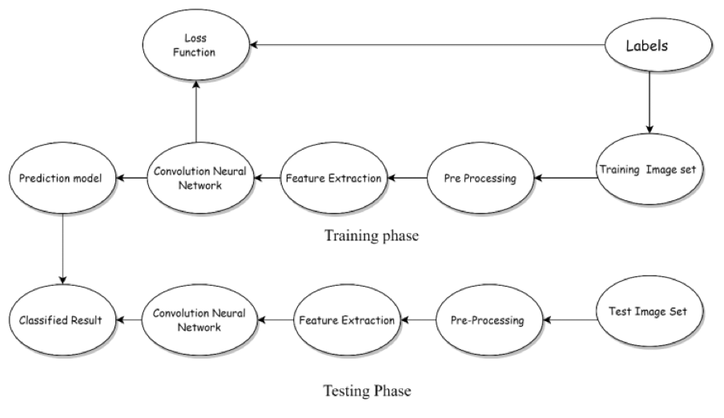

**2.8 Assumption and Dependencies:**

User uploads the image according to the image format which is accepted by the system.

Image uploaded is of the different varieties of apples, bananas or oranges.

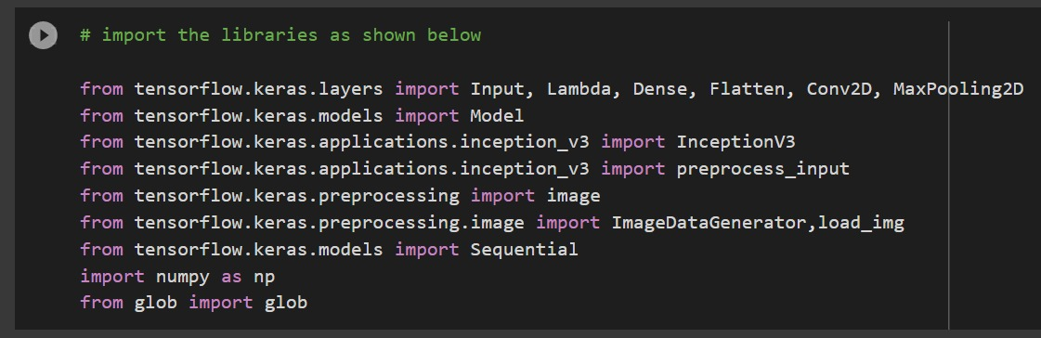

**SYSTEM REQUIREMENTS**

A regular system with 4GB of RAM and 200GB of HDD along with python installed with all the necessary libraries is all it takes to run the project.

**3.1 User Interface:**

Any IDE suitable for python like Jupyter notebook, Google Colab, VS Code can be used as an interface.

**3.2 Software Interface:**

A Graphic User Interface (GUI) will not be there.

**3.3 Database Interface:**

Database solution has been used from Kaggle. The data was organised again for the project.

**NON-FUNCTIONAL REQUIREMENTS**

**4.1 Performance requirements:**

4GB of RAM and python installed with all the necessary libraries is all it takes to run the project.

**4.2 Security requirements:**

Normal system security needed.

**4.3 Software Quality Attributes:**

1. **Availability:** The system will consistently be accessible for access at 24 hours, 7 days per week.
2. Additionally, in the event of any significant framework failing, the system will be accessible in 1 to 2 working days, so business process isn't seriously influenced.
3. **Maintainability:** The developer should maintain correct relations in the algorithms.
4. **Flexibility:** A straightforward however quality UI will be created to make it straightforward and can accept all kinds of images as input.
5. **Usability:** The image should be of the format as required by the system.

**Other Requirements:**

There are no such Other Requirements Needed.

**Appendix A: Glossary**

IDE: Integrated development environment

**Approved by**

**Dr. Hitesh Kumar Sharma Dr. Hitesh Kumar Sharma**

Program Lead Program Lead

(Cybernetics Cluster) (Cybernetics Cluster)

Project Mentor Head of Department